## Front End Engineering-II

Project Report

Semester-IV (Batch-2022)

Title of the Project: Sushi Sensation



**Supervised By: Submitted By:**

Raveesh Samkaria Name: Tanisha

Roll no: 2210990891

Group: G-13

**Department of Computer Science and Engineering**

## Chitkara University Institute of Engineering & Technology,

## Chitkara University, Punjab

**CONTENTS:**

|  |  |  |  |
| --- | --- | --- | --- |
| **S.NO** | **CONTENT** | | **PAGE.NO** |
| **1** | **Introduction** | | **3-5** |
| **3** | **Problem Definition and Requirements** | | **6-7** |
| **4** | **Technical Details** | | **8-10** |
| **5** | **File Structure** | | **11-12** |
| **6** | **Proposed Design/Methodology** | | **13-15** |
| **7** | **Source Code** | | **16-21** |
| **8**  **9** | **Result**  **Reference** | **22-30**  **31** | |

**Introduction:**

**The sushi restaurant website project emerges from a confluence of culinary passion and digital innovation, aiming to bridge the gap between traditional gastronomy and modern online engagement. In an increasingly digital-centric world, where the internet serves as a primary gateway for exploration and interaction, establishing a robust online presence has become imperative for businesses across various industries. Within the culinary landscape, this paradigm shift presents both challenges and opportunities, prompting restaurants to adapt and leverage digital platforms to connect with their audience effectively.**

**Background:**

**Sushi, an iconic Japanese cuisine celebrated for its exquisite craftsmanship and cultural significance, embodies a culinary tradition that transcends borders and captivates palates worldwide. Rooted in centuries-old techniques and philosophies, sushi dining represents not just a meal but an immersive experience—an artful symphony of flavors, textures, and aesthetics. However, in an era marked by rapid globalization and technological advancement, the landscape of culinary consumption has evolved, with diners increasingly turning to digital channels to discover, engage with, and patronize restaurants.**

**Against this backdrop, the sushi restaurant website project seeks to address the evolving needs and preferences of contemporary diners while honoring the time-honored traditions and values of sushi craftsmanship. By harnessing the power of web development and design, the project endeavors to create an immersive online platform that not only showcases the restaurant's culinary offerings but also fosters meaningful engagement and connection with its audience.**

**Objective:**

**The primary objective of the sushi restaurant website project is to design and develop a visually captivating, user-friendly, and informative online platform that encapsulates the essence of the restaurant's brand and dining experience. Specifically, the project aims to:**

**1. Create an engaging and aesthetically pleasing user interface that mirrors the ambiance and sophistication of the physical dining environment.**

**2. Provide comprehensive information about the restaurant's menu, ingredients, preparation techniques, and culinary philosophy to educate and entice visitors.**

**3. Enable seamless online interactions, such as making reservations, placing orders, and providing feedback, to enhance the convenience and accessibility of the dining experience.**

**4. Showcase the restaurant's commitment to quality, authenticity, and innovation through compelling visuals, testimonials, and interactive elements.**

**5. Cultivate a sense of community and loyalty among patrons by offering value-added content, promotions, and opportunities for social sharing and participation.**

**Significance:**

**The significance of the sushi restaurant website project lies in its ability to serve as a dynamic digital storefront and communication hub for the restaurant, enabling it to effectively reach, engage, and retain customers in an increasingly competitive market landscape. By embracing digital transformation and embracing user-centric design principles, the project not only enhances the restaurant's visibility and accessibility but also fosters deeper connections and relationships with its audience.**

**Moreover, the project holds broader implications for the culinary industry as a whole, highlighting the evolving role of digital technology in shaping the way we discover, experience, and appreciate food. By leveraging the power of storytelling, visual aesthetics, and interactive experiences, the project seeks to elevate sushi dining beyond a mere transactional exchange to a holistic journey of exploration, discovery, and cultural immersion.**

**In essence, the sushi restaurant website project represents a symbiotic fusion of culinary artistry and digital ingenuity—a testament to the enduring allure of sushi dining in an ever-evolving digital landscape. Through its commitment to excellence, innovation, and authenticity, the project aims to redefine the boundaries of gastronomic exploration and inspire a new generation of sushi enthusiasts and connoisseurs.** Ultimately, the sushi restaurant website project represents a convergence of culinary craftsmanship, digital innovation, and cultural appreciation—a testament to the enduring allure of sushi dining in an increasingly interconnected world. Through its holistic approach to online branding and engagement, the project seeks to not only elevate the restaurant's digital footprint but also inspire a deeper appreciation for the artistry and tradition of sushi among global audiences.

**Problem Definition and Requirements**

The sushi restaurant industry faces the challenge of adapting to the evolving preferences of modern diners while maintaining the authenticity and allure of traditional culinary experiences. In this context, the primary problem is the need for the restaurant to establish a robust online presence that effectively communicates its brand identity, culinary offerings, and values to a diverse and digitally savvy audience. Additionally, there is a requirement for seamless online interactions, such as reservations, orders, and feedback, to enhance the convenience and accessibility of the dining experience.

**Problem Statement:**

The sushi restaurant website project aims to address the following key challenges:

1. Limited Visibility: The restaurant struggles to reach and engage with potential customers in an increasingly crowded online marketplace, leading to missed opportunities for business growth and customer acquisition.

2. Lack of Online Interaction: Without a comprehensive online platform, the restaurant faces difficulties in facilitating essential interactions, such as reservations, orders, and feedback, hindering customer convenience and satisfaction.

3. Brand Differentiation: In a competitive culinary landscape, the restaurant needs to differentiate itself from competitors and communicate its unique value proposition effectively to attract and retain customers.

**Software Requirements:**

1. Web Development Framework: Choose a suitable framework for web development, such as React.js to build a dynamic and responsive website.

2. Content Management System (CMS): Implement a CMS like WordPress or Drupal to manage and update website content efficiently, including menus, images, and promotional materials.

3. Database Management System (DBMS): Utilize a DBMS like MySQL, MongoDB, or PostgreSQL to store and manage user data, reservations, orders, and other relevant information securely.

4. Frontend Technologies: Employ HTML, CSS, and JavaScript along with any necessary libraries or frameworks to create an intuitive and visually appealing user interface.

**Hardware Requirements:**

1. Web Server: Deploy the website on a reliable web hosting server capable of handling expected traffic volumes and ensuring optimal performance and uptime.

2. Development Environment: Set up development workstations with adequate processing power, memory, and storage capacity to facilitate smooth software development and testing processes.

3. Networking Infrastructure: Ensure a stable internet connection and network infrastructure to support seamless communication between server-side and client-side components.

**Technical Details:**

The provided code comprises a React.js application for a sushi restaurant website. Here are the technical details:

**1. Frontend Development:**

React.js: The codebase is built using React.js, a JavaScript library for building user interfaces. React components are utilized to create reusable UI elements such as Navbar, HeroSection, PopularMenu, Product, Statistics, AboutUs, Testimonials, Contact, and Footer.

HTML & CSS: HTML and CSS are used for structuring the layout and styling the components, respectively. CSS classes are applied using classNames to style the components, with some styles defined inline.

Assets: Image assets are imported and utilized within the components to enhance visual appeal.

**2. Component Structure:**

The application is divided into multiple components, each responsible for rendering a specific section of the website.

Components include Navbar, HeroSection, PopularMenu, Product, Statistics, AboutUs, Testimonials, Contact, and Footer.

**3. Functional Components:**

All components are functional components, leveraging React's useState hook for managing local component state where applicable.

JSX syntax is used within the components to define the structure of the UI elements.

**4. Styling:**

CSS files are imported into the components to apply styling. Tailwind CSS utility classes are utilized for responsive design and layout management.

Inline styles are also applied directly within JSX for specific styling requirements.

**5. Dynamic Data Rendering:**

Some components, such as PopularMenu and Statistics, render dynamic data passed as props. For example, the PopularMenu component renders sushi images and descriptions, while the Statistics component displays numerical data.

**6. Image Rendering:**

Images are imported and rendered within the components to enhance visual presentation. Images are sourced from the assets folder and displayed using the img tag.

**7. Interactivity:**

Links are incorporated within the Navbar component to enable navigation between different sections of the website.

Buttons are utilized for call-to-action elements, such as ordering and subscribing.

**8. Responsive Design:**

The application is designed to be responsive, ensuring optimal display across various screen sizes and devices.

Tailwind CSS utility classes are utilized for responsive design, specifying layout and spacing based on screen breakpoints.

Overall, the codebase demonstrates effective utilization of React.js and modern web development practices to create a visually appealing and interactive sushi restaurant website.

**File Structure:**

**public:** Contains static assets and the HTML file where the React application is mounted.

**src:** Contains the source code of the React application.

**components:** Directory for React components, each representing a different section of the website.

**assets:** Directory for application-specific assets like images and SVGs

**App.css:** Stylesheet for the App component or global styles.

**App.js:** Main component where other components are imported and rendered.

**index.css:** Global styles for the application.

**index.js:** Entry point of the React application where ReactDOM.render() is called to mount the root component onto the HTML document.

**package.json:** Configuration file that includes project metadata and dependencies.

**README.md:** README file containing information about the project, its setup, and usage instructions.

**other configuration files:** Any other configuration files required for the project, such as ESLint configuration, webpack configuration, etc.

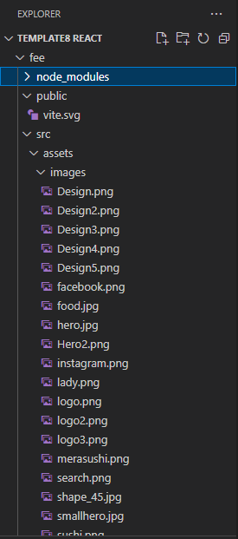 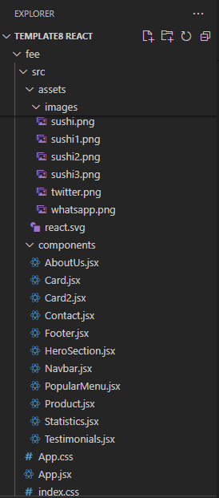 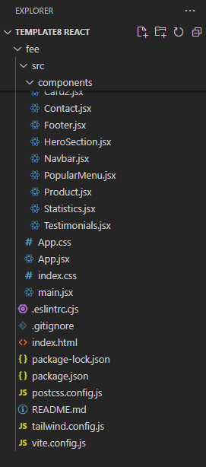

**Proposed Design / Methodology** 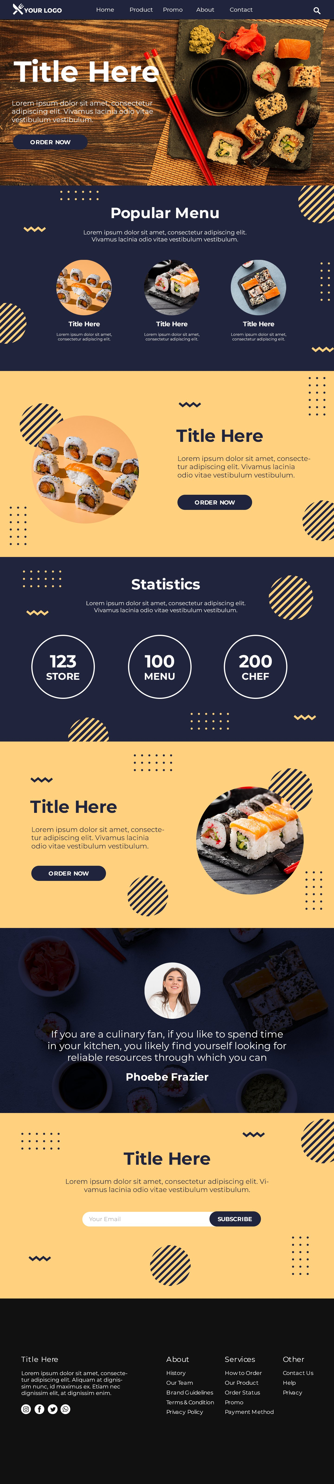



**Source code:**

**APP.JSX:**

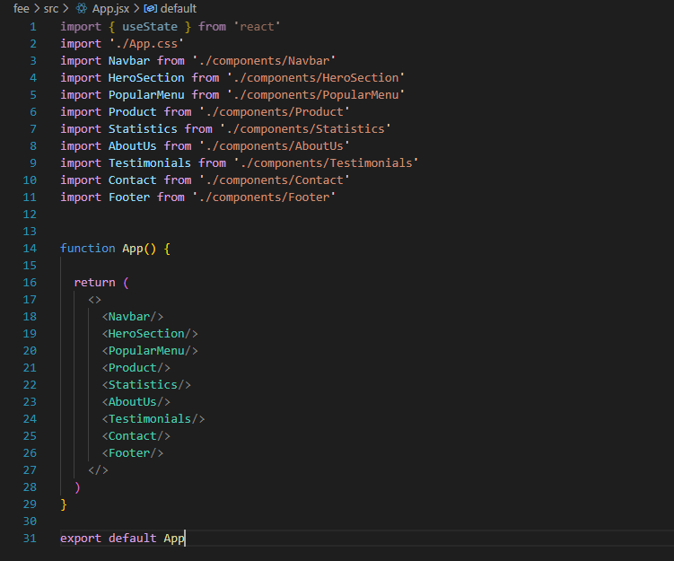

**Navbar.jsx:**

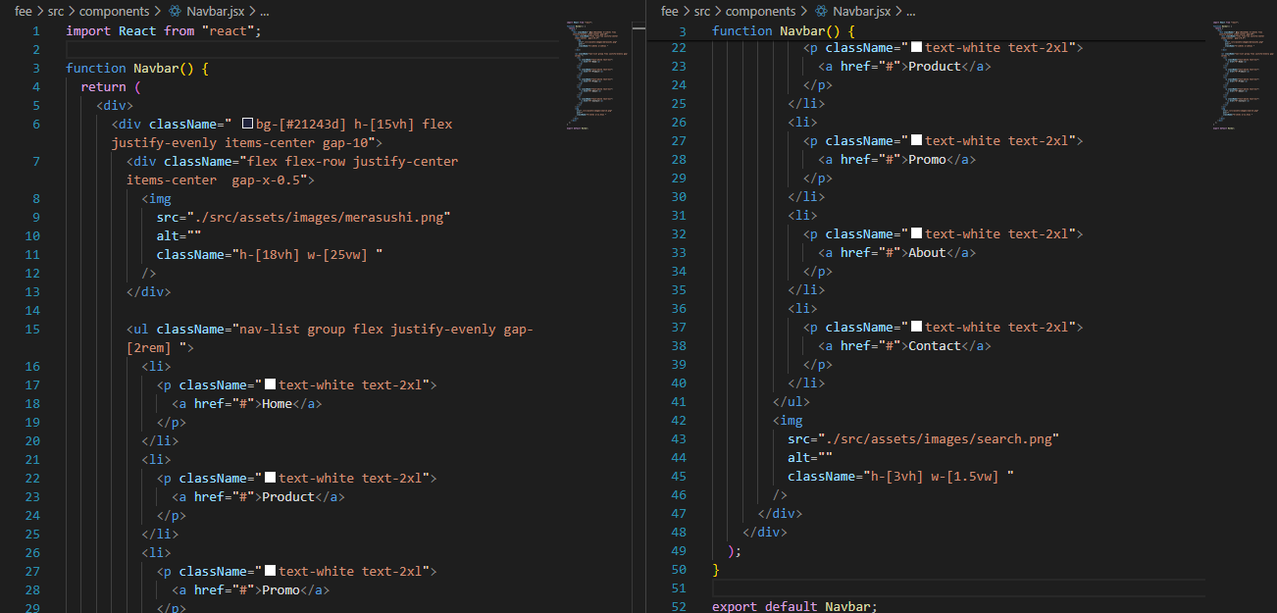

**HeroSection.jsx:**

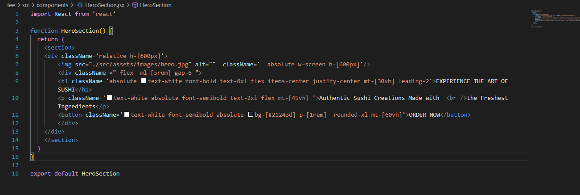

**PopularMenu.jsx:**

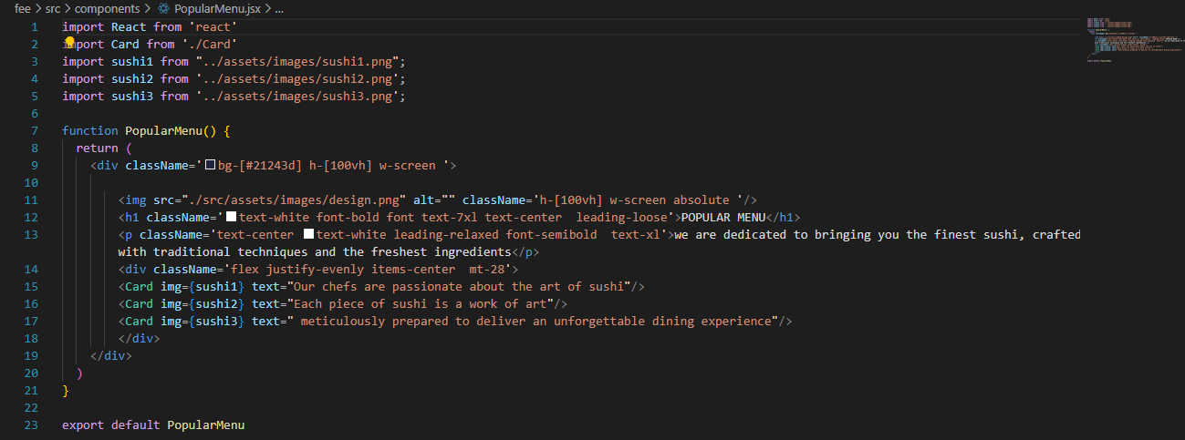

**Product.jsx:**

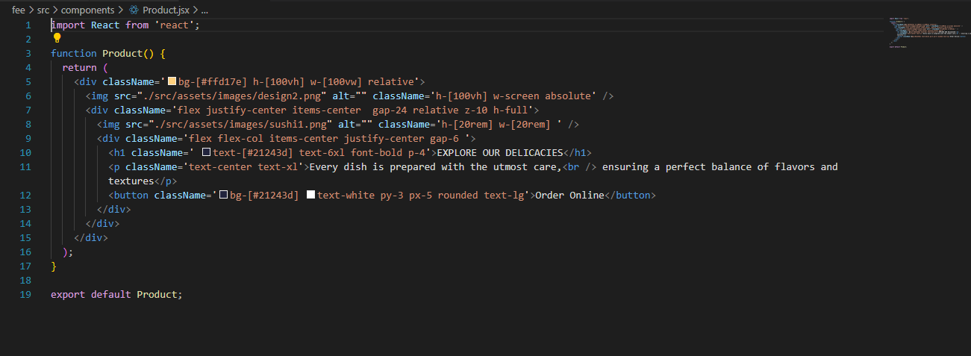

**Statistics.jsx:**

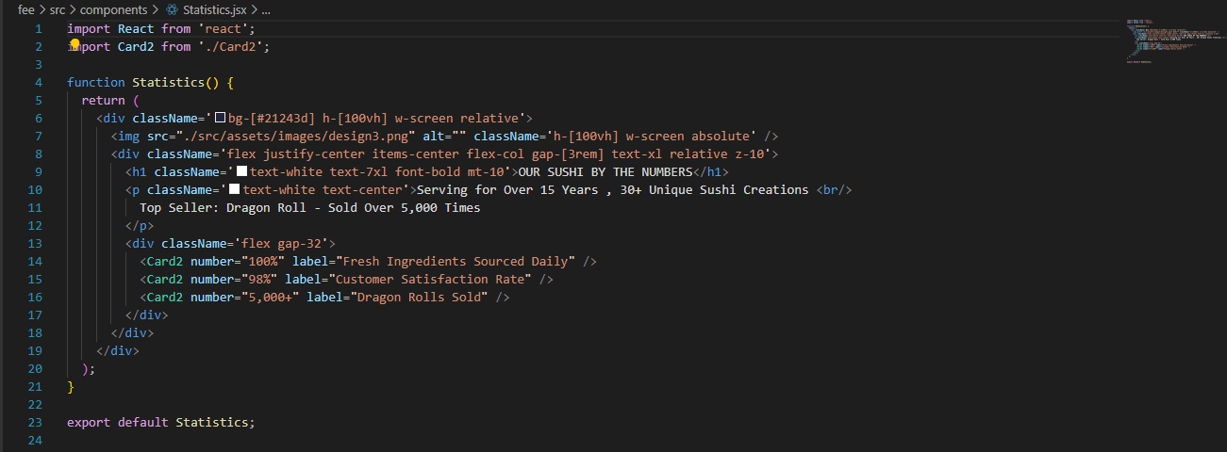

**AboutUs.jsx:**

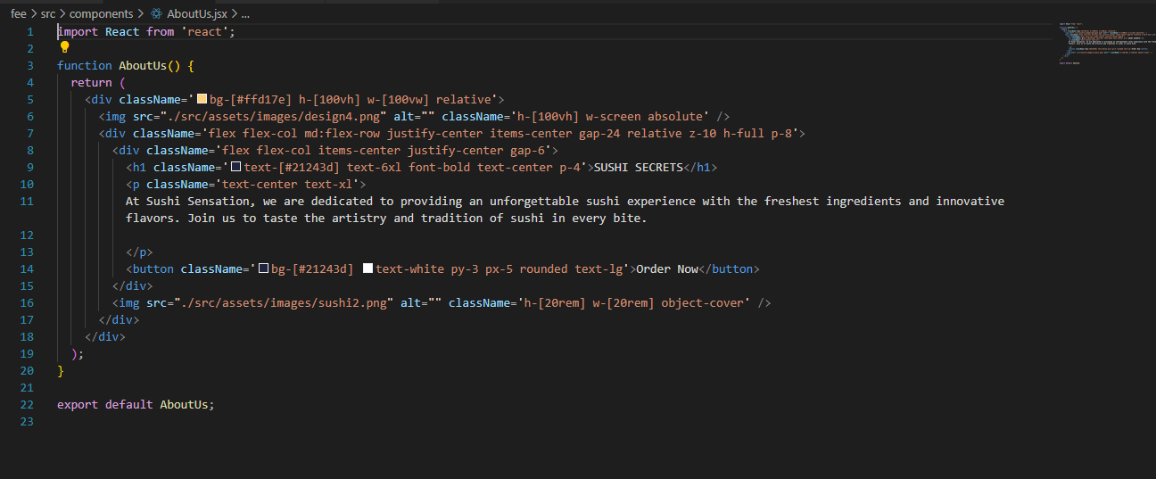

**Testimonials.jsx:**

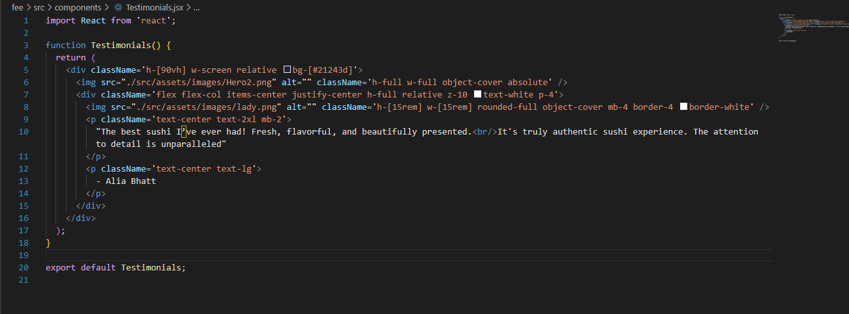

**Contact.jsx:**

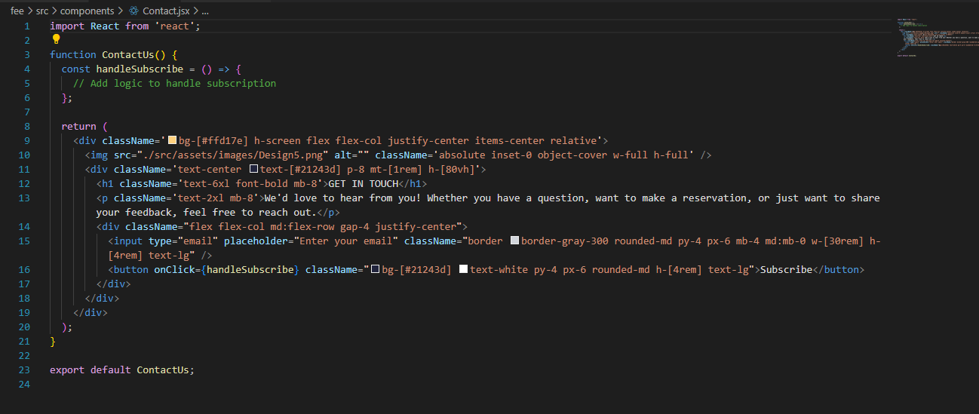

**Footer.jsx:**

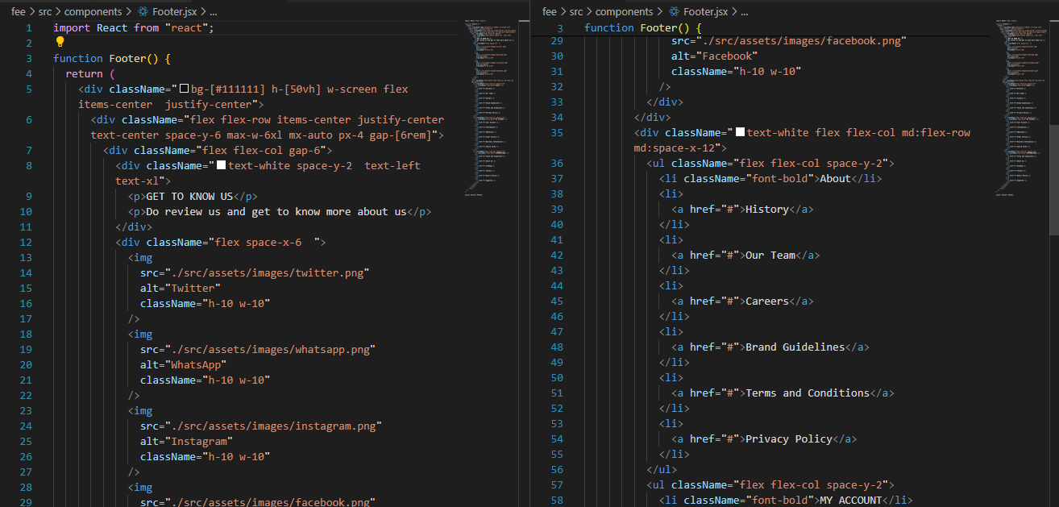

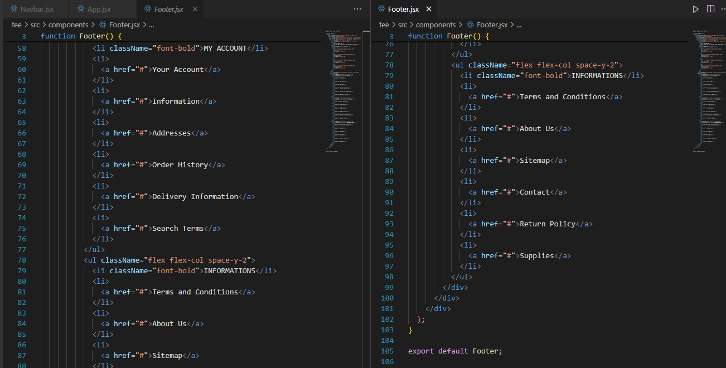

**Card.jsx:**

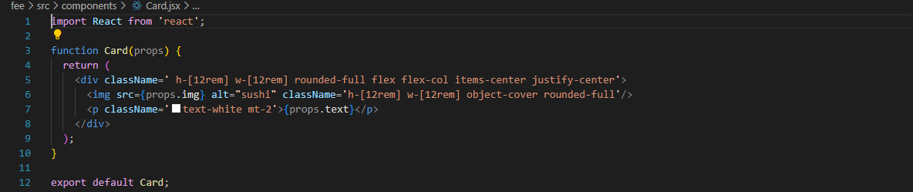

**Card2.jsx:**

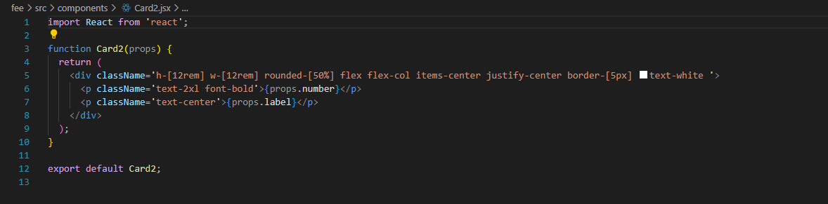

**Result:**

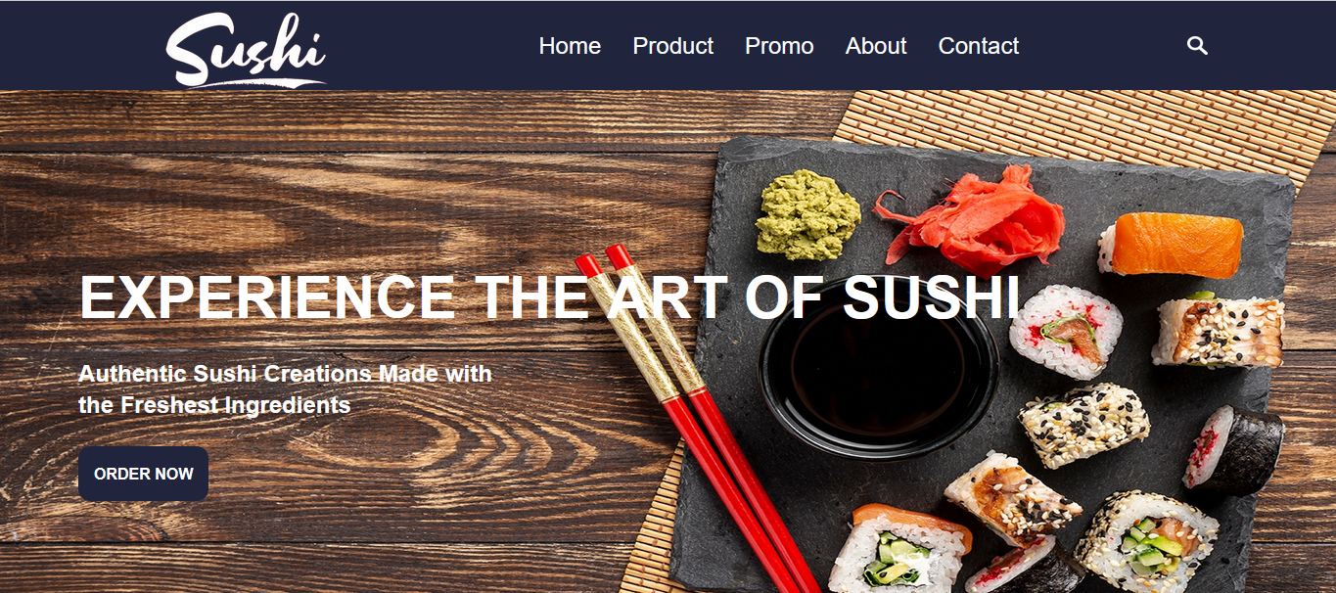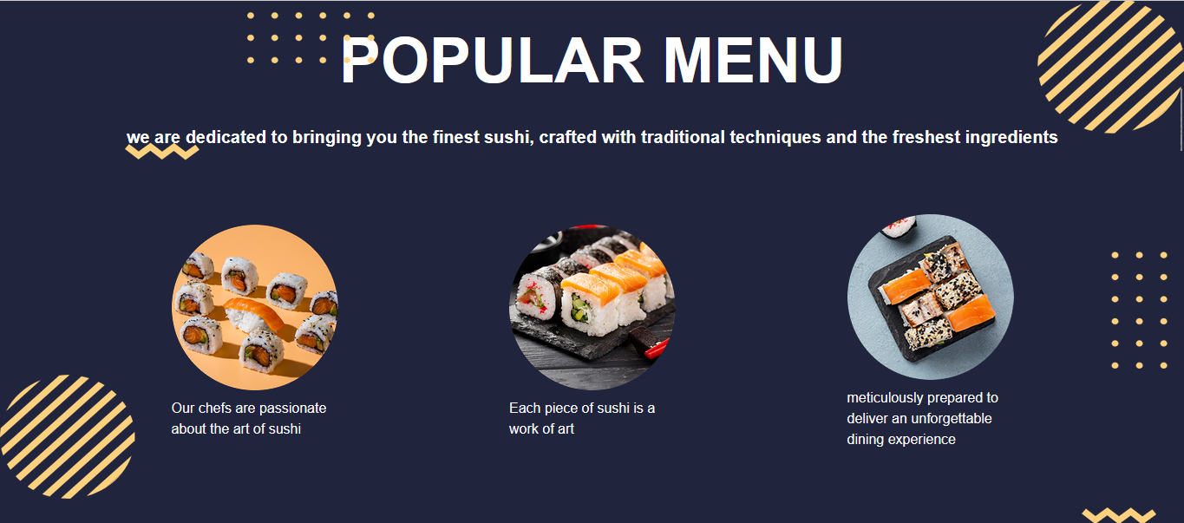

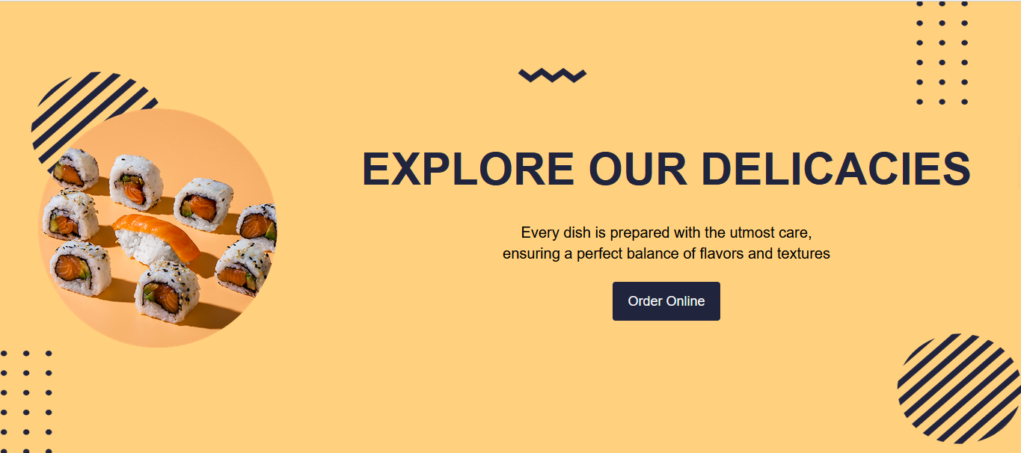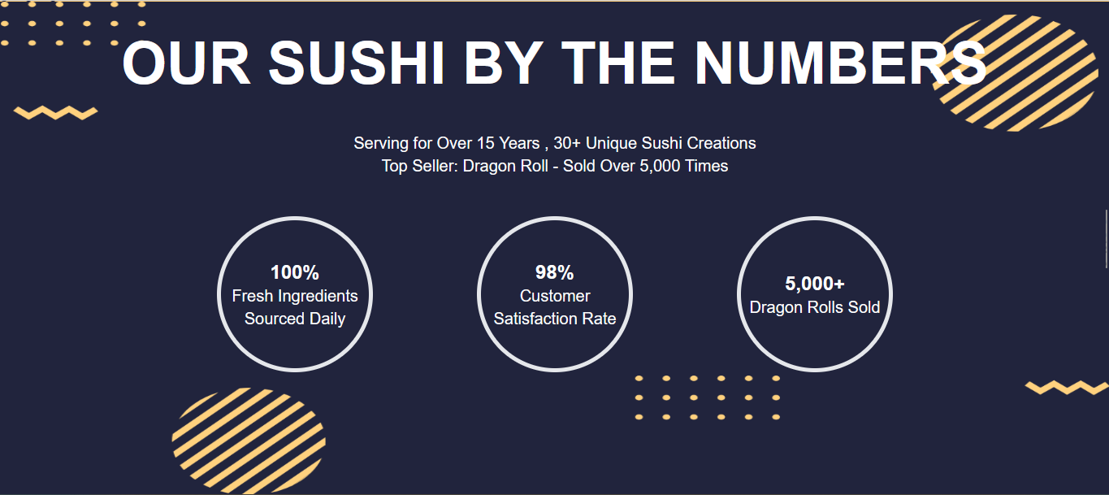

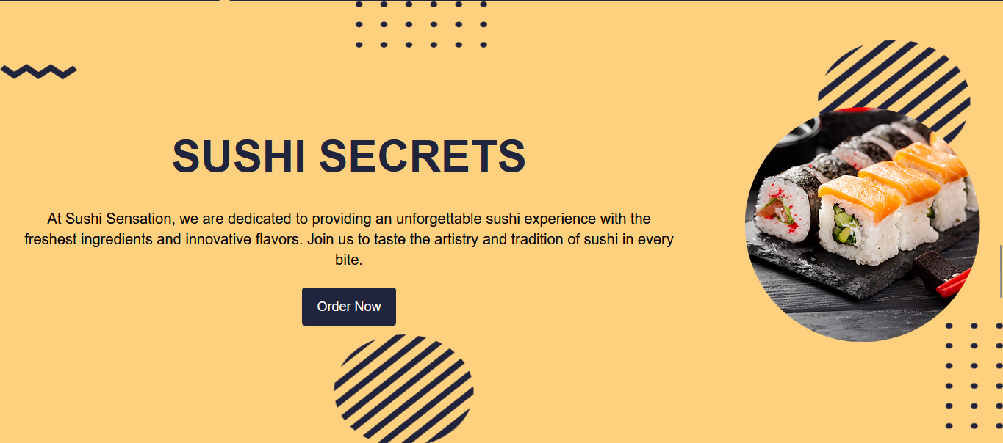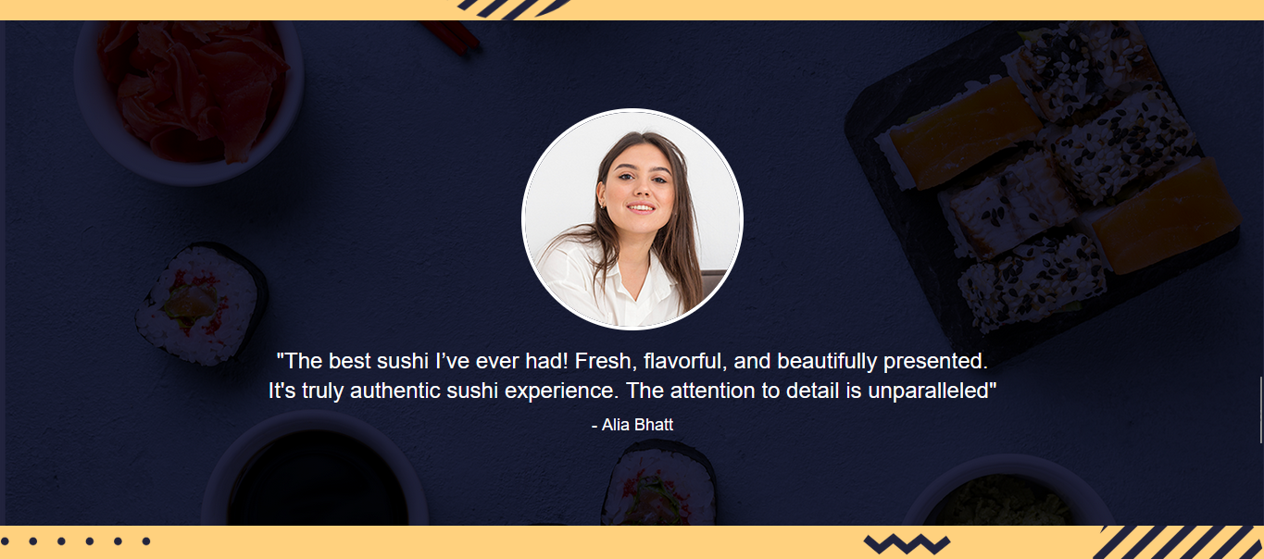

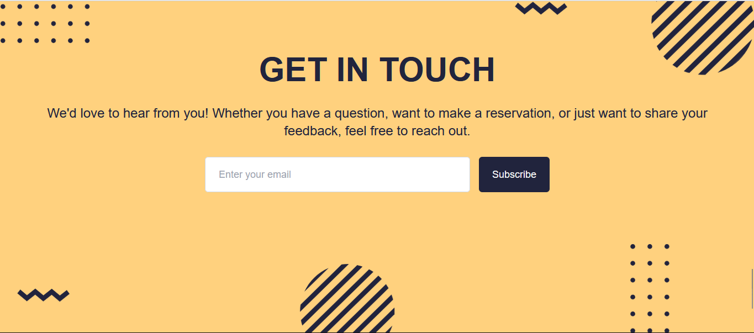

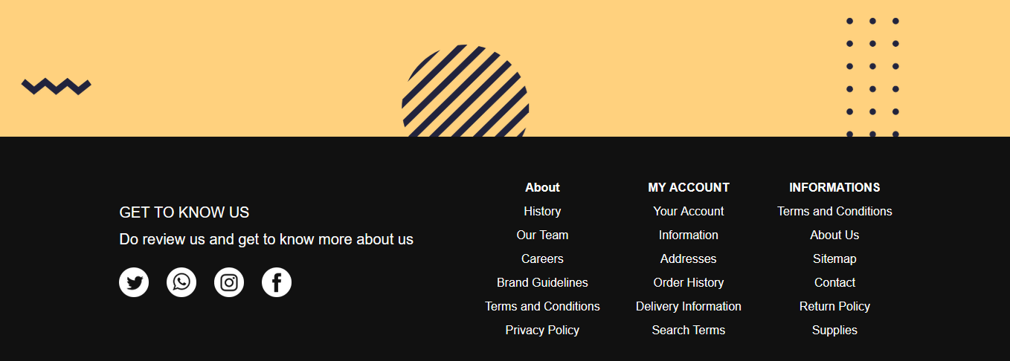

**Responsive Design:**

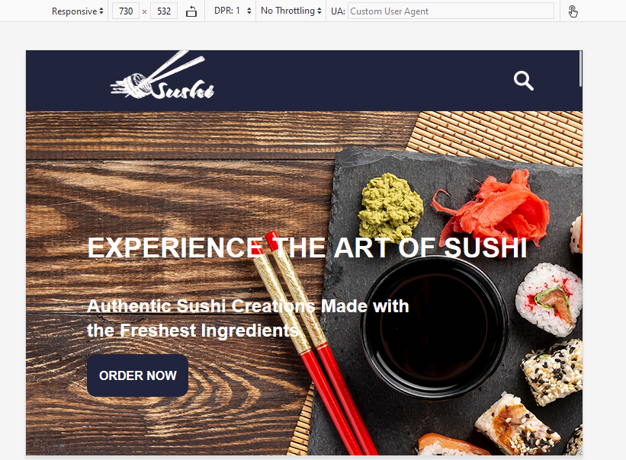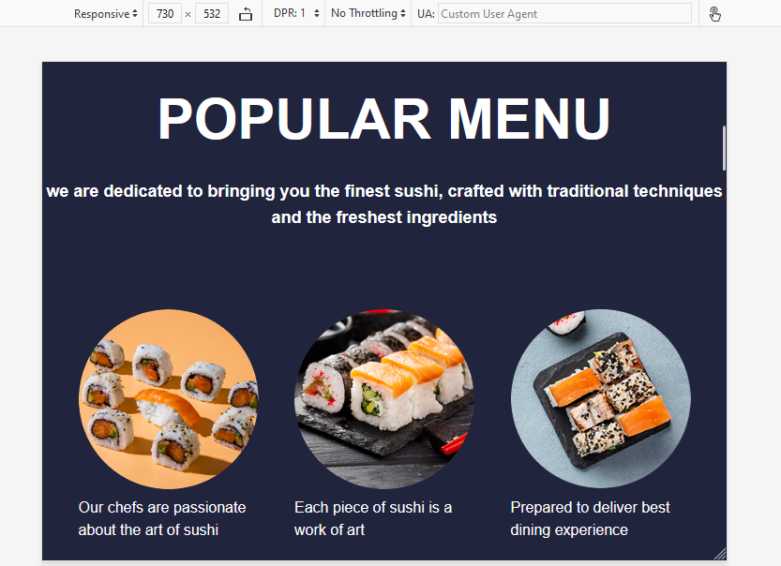

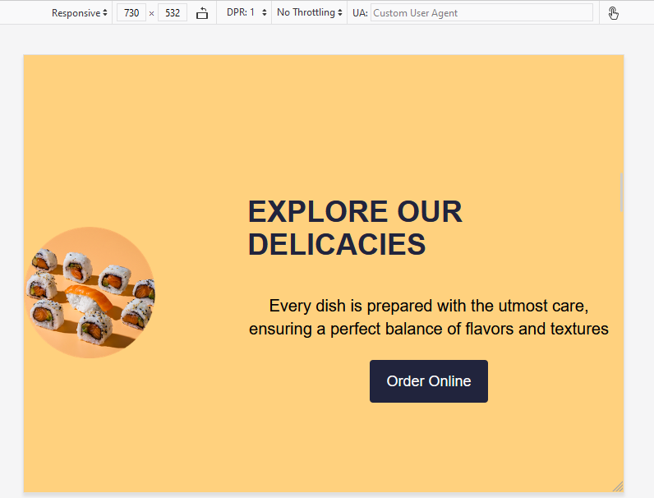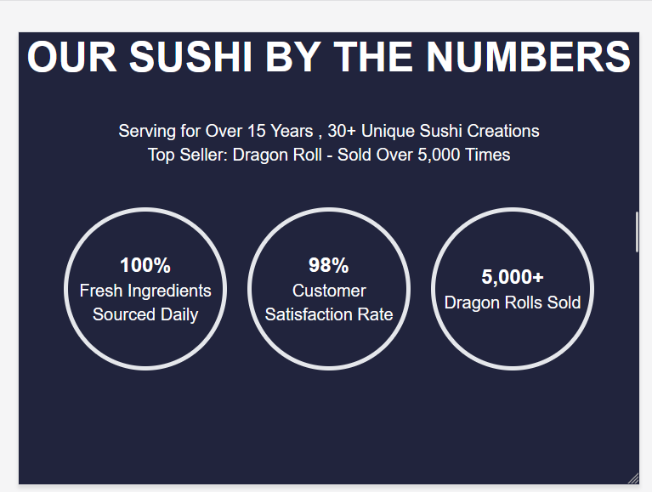

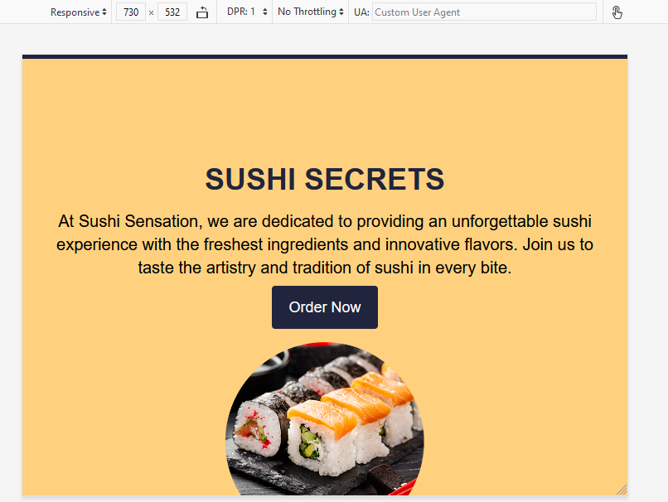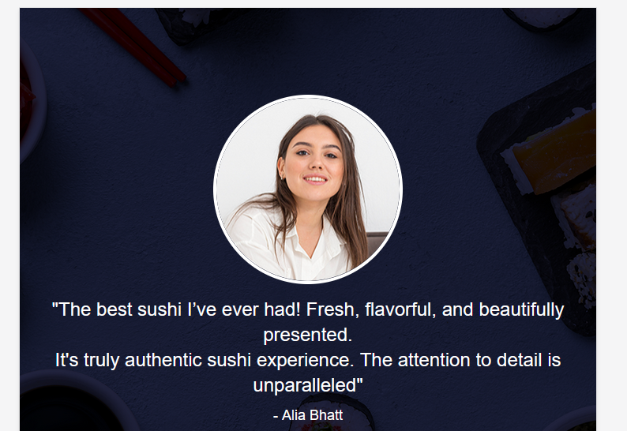

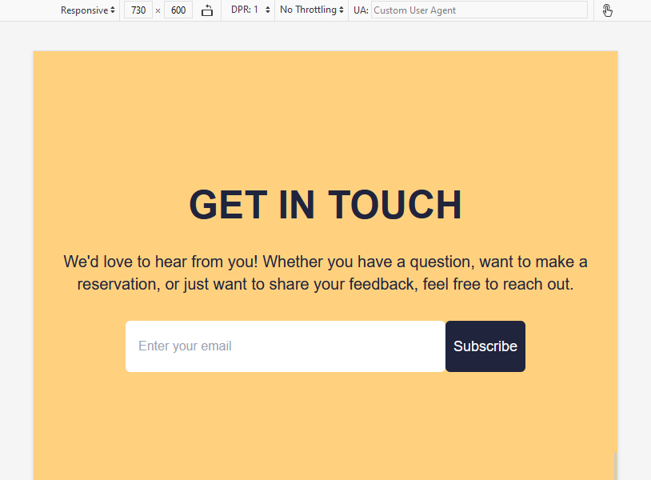

**Reference:**

**1. Photopea:** [**https://www.photopea.com/**](https://www.photopea.com/)

**2. Google Fonts:** [**https://fonts.google.com/**](https://fonts.google.com/)

**3. Tailwind CSS:** [**https://tailwindcss.com/**](https://tailwindcss.com/)

**4. Vite:** [**https://vitejs.dev/**](https://vitejs.dev/)

**5. w3 schools:** [**https://www.w3schools.com/**](https://www.w3schools.com/)

**6. React js:** [**https://react.dev/**](https://react.dev/)